LAB REPORT

(Names) Qi Lin, Sajana Wijesinghe
(Date) 11/07/18

Title: Lab Number 7
Statement of the Problem:

Question:
- How are we able to use an Arduino and the IDE program to measure the distance and velocity using Parallax PING Ultrasonic Distance Sensor

Materials:
- Arduino UNO microcomputer
- PC with Arduino IDE installed
- USB cable
- Parallax PING Ultrasonic Distance Sensor

Procedure:
- First, we begin by setting up our components together as shown in the picture below.
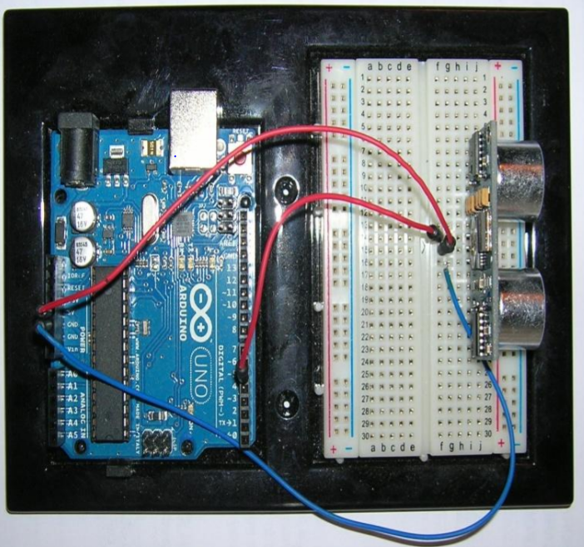

- Once this is set up, connect it to the PC using the USB Cable.
- If your set up is correct, there should be a light on the Arduino board. This mean that your circuit is complete.
- Next, you begin to type the following code in the Arduino.exe program

const int pingPin =5; -pin attached to PING sensor
int d; - current value of distance
int dOld; -previous value of distance
int DELTA_T = 1000; -sampling time interval in milliseconds

void setup(){
Serial.begin(9600);
}

void loop(){
dOld = d;
d = ping(pingPin);
int v = 1000 * (d - dOld) / DELTA_T;
Serial.print("D: ");
Serial.print(d);
Serial.print("/V: ");
Serial.println(v);
delay(DELTA_T);
}

int ping(int pingPin)
{
int duration; /* duration of round trip
pulse in microseconds */

pinMode(pingPin, OUTPUT); /* set pingPin for output
first */
digitalWrite(pingPin, LOW); /* write a LOW value for a
short time */
delayMicroseconds(2);
digitalWrite(pingPin, HIGH); /* send a pulse at least 5
microseconds in length */
delayMicroseconds(5);
digitalWrite(pingPin, LOW); /* end the pulse */

pinMode(pingPin, INPUT); /* set the pingPin for
input */
duration = pulseIn(pingPin, HIGH); /* and get round trip
duration in microseconds */
/* sound velocity is 29
centimeters per microsecond */

/* distance is half of the
round trip */
return duration / 29 / 2; /* convert to centimeters
*/
}

- Once you are done coding, compile and run it. Afterward open the serial monitor to see the output of the sensor.

Serial Monitor Output:

D: 9/V: 0
D: 6/V: -3
D: 4/V: -2
D: 11/V: 7
D: 28/V: 17
D: 27/V: -1
D: 27/V: 0
D: 3/V: -24
D: 5/V: 2
D: 6/V: 1
D: 4/V: -2
D: 27/V: 23

- Depending on what is in front of the sensor, the values will change.
- Don’t forget to connect to the right port (any port except Port 1, Port 2, Port 3

Conclusions:

- There are a couple of things that I have learned from the lab. The first thing is about the interfacing hardware to a microprocessor and its software. I learned more about sensors and how they work. Overall, it was a fun lab.

- Potential Errors:
  - Connecting the wires in the wrong location
  - Selecting the wrong COM port i.e. Port 1, Port 2 and Port 3
  - Using a faulty Parallax PING Ultrasonic Distance Sensor.

